IoT-Based Smart Gas Leakage and Flame Detection System
Submitted in partial fulfilment of the requirements of the degree of
Bachelor of Engineering
In
Computer Science and Engineering (Data Science)

by
Soham Gunjal [PID No. EU8057]
Aditi Patil [PID No. EU8059]
Suraj Sawant [PID No. EU8060]
Shubhra Shinde [PID No. EU8061]

Under the Guidance of
Mr. Sachin Sase
Assistant Professor, Department of Computer Science and Engineering (Data Science), SJCEM



DEPARTMENT OF COMPUTER SCIENCE AND ENGINEERING (DATA SCIENCE)
ST. JOHN COLLEGE OF ENGINEERING & MANAGEMENT
UNIVERSITY OF MUMBAI

2026-2027



Certificate of Approval

This is to certify that Soham Gunjal (PID: 8057), Aditi Patil (PID: 8059), Suraj Sawant (PID: 8060), and Shubhra Shinde (PID: 8061), are bonafide students of B. Tech in Computer Science and Engineering (Data Science) Department, St. John College of Engineering and Management, Mumbai. They have satisfactorily completed the requirements of Synopsis as prescribed by ST. JOHN COLLEGE OF ENGINEERING AND MANAGEMENT (An Autonomous College affiliated to University of Mumbai), while working on “IoT-Based Smart Gas Leakage and Flame Detection System”.

Signature : _____________________  Name : Mr. Sachin Sase  Designation : Assistant Professor  Department : CSE (Data Science), SJCEM | Signature : _____________________  Name : Mrs. Joslyn Gracias  Designation : Head of Department  Department : CSE (Data Science), SJCEM

Signature:
Name : Dr. Kamal Shah Principal,
St. John College of Engineering and Management.

Declaration

I/we declare that this written submission represents my/our ideas in my/our own words and where others ideas or words have been included, I/we have adequately cited and referenced the original sources. I/we also declare that I/we have adhered to all principles of academic honesty and integrity and have not misrepresented or fabricated or falsified any idea/data/fact/source in my/our submission. I/we understand that any violation of the above will be cause for disciplinary action by the Institute and can also evoke penal action from the sources which have thus not been properly cited or from whom proper permission has not been taken when needed.

Signatures of Students:

1. _______________________ 2. _______________________
Soham Gunjal (PID: 8057) Aditi Patil (PID: 8059)
3. _______________________ 4. _______________________
Suraj Sawant (PID: 8060) Shubhra Shinde (PID: 8061)

Date: 20th October, 2026 Place: Palghar, Mumbai

Acknowledgement
We express our sincere gratitude to all those who have directly and indirectly contributed to the successful preparation of this project synopsis.
We are deeply grateful to Dr. Kamal Shah, Principal, St. John College of Engineering and Management, for providing an excellent academic environment and the necessary facilities to undertake this project.
We extend our heartfelt thanks to the Mrs. Joslyn Gracias, Head of the Department of Computer Science and Engineering (Data Science) for their constant encouragement, valuable suggestions, and continuous support throughout the preparation of this synopsis.
We would like to express our sincere appreciation to our project guide, Mr. Sachin Sase, Assistant Professor, Department of Computer Science and Engineering (Data Science), for his invaluable guidance, constructive suggestions, technical expertise, and continuous motivation. His encouragement and insightful feedback have been instrumental in shaping this project synopsis.
We also acknowledge all the faculty members and laboratory staff of the Department of Computer Science and Engineering (Data Science) for their timely assistance, cooperation, and technical support.
Finally, we express our heartfelt gratitude to our parents, family members, friends, and classmates for their constant encouragement, moral support, and cooperation throughout this work.

Group Members:
- Soham Gunjal [PID No. EU1258057]
- Aditi Patil [PID No. EU1258059]
- Suraj Sawant [PID No. EU8060]
- Shubhra Shinde [PID No. EU1258061]
ABSTRACT

Liquefied Petroleum Gas (LPG) and flammable hydrocarbon gases are universally utilized across domestic kitchens, educational laboratories, and industrial environments. However, undetected gas leakages and subsequent fire ignitions present severe threats to human life, public infrastructure, and assets. Conventional alarm systems suffer from critical limitations: they offer only single-hazard monitoring, lack immediate human-intelligible audio voice guidance, and fail to provide remote real-time telemetry when premises are unoccupied.

To address these critical shortcomings, this project proposes the design and implementation of an 'IoT-Based Smart Gas Leakage and Flame Detection System'. The proposed architecture leverages the NodeMCU ESP8266 microcontroller as a low-cost, high-performance edge processing core. The system incorporates a dual-hazard sensing array featuring an MQ-2 metal-oxide semiconductor gas sensor for volatile gas/smoke response and an infrared (IR) flame sensor for optical fire detection. An embedded firmware routine applies a multi-sample moving average filter to suppress ambient electrical and environmental noise before performing dual-threshold hazard classification.

Upon hazard detection, the system triggers a coordinated multi-tier response: localized visual alerts via bi-color LEDs, a high-decibel active piezo buzzer, and an ISD1820 voice playback module that delivers clear, spoken evacuation prompts (e.g., 'Warning! Gas leakage detected, vacate and ventilate the premises'). Concurrently, the integrated ESP8266 Wi-Fi transceiver dispatches real-time telemetry to an IoT cloud dashboard, providing remote situational awareness. Crucially, the system features fail-safe local autonomy, ensuring prompt acoustic and voice alarms even during network outages. The prototype achieves sub-2-second response latency, exceptional cost-effectiveness, and direct alignment with United Nations Sustainable Development Goals (SDG 3, SDG 9, and SDG 11).
C O N T E N T S

- List of Figures
- List of Tables
- Abbreviations and symbols

Chapter No. | Topic | Page No.
Chapter 1 | Introduction: Background, Problem Statement, Need, Objectives, Scope, Expected Outcomes | 1
Chapter 2 | Literature Review: Survey table, Research Gap, Novelty/Innovation | 4
Chapter 3 | Proposed Methodology: Working Principle, Architecture/Block Diagram, Flowchart, Methodology, Components | 7
Chapter 4 | Project Planning: WBS, Gantt Chart, Roles, Risk Assessment | 14
Chapter 5 | Resources & Feasibility: Technical/Economic/Operational Feasibility, Budget, BOM | 16
Chapter 6 | Expected Results & Impact: Expected outcomes, Industrial relevance, Sustainability, SDG mapping, Future Scope | 18
Chapter 7 | Conclusion | 20
References | IEEE style; 16 references | 21
Appendix | CAD drawings, calculations, pinout mapping, IoT schema (optional) | 23

List of Figures

Figure No. | Figure Name | Page No.
1 | DFD | 8
2 | Block Diagram | 9
3 | Flow Chart | 10
4 | UML | 11
5 | GUI 01 | 12
6 | GUI 02 | 12
7 | GUI 03 | 13

List of Tables

Table No. | Table Name | Page No.
1 | Survey Table | 4 to 6
2 | Planning Table | 14

Abbreviations and symbols

- IoT: Internet of Things
- MCU: Microcontroller Unit
- NodeMCU: Open-source Lua / C++ Firmware Development Board (ESP8266)
- MQ-2: Tin Dioxide (SnO2) Semiconductor Combustible Gas and Smoke Sensor
- IR: Infrared Optical Radiation
- ADC: Analog-to-Digital Converter
- GPIO: General Purpose Input/Output
- ISD1820: Single-Chip Voice Recording and Direct Audio Playback Module
- LED: Light Emitting Diode
- LPG: Liquefied Petroleum Gas (Propane / Butane mixture)
- Wi-Fi: Wireless Fidelity (IEEE 802.11 b/g/n Standard)

CHAPTER 1: INTRODUCTION

1.1 Background
Liquefied Petroleum Gas (LPG)—primarily comprising propane (C3H8) and butane (C4H10)—is an indispensable fuel source for residential cooking, academic laboratories, catering institutions, and manufacturing processes worldwide. Despite its clean combustion and high thermal efficiency, LPG possesses physical properties that create severe occupational and domestic hazards. It is inherently heavier than ambient air; thus, upon inadvertent escape from cylinders, regulators, or degraded rubber hoses, it does not dissipate freely into the upper atmosphere. Instead, leaked vapor descends and pools along floor surfaces, basements, and unventilated corners. In this concentrated condition, even minor ignition triggers—such as an electrical light switch spark, static discharge, or hot surface—can instantly ignite the gas cloud, precipitating devastating flash fires or high-velocity pressure explosions.
The Internet of Things (IoT) paradigm provides a transformative opportunity to overcome the vulnerabilities of traditional safety apparatus. By integrating miniature, low-power embedded microcontrollers with specialized solid-state environmental transducers and optical sensors, physical surroundings can be continuously monitored in real time. Intelligent edge nodes can immediately identify anomalous atmospheric concentrations, initiate local autonomous countermeasures, and transmit telemetry to remote web dashboards and cloud alerting services.

1.2 Problem Statement
Existing Problem: Human sensory perception is completely unreliable for early gas detection, particularly during nocturnal sleeping hours or when occupants are temporarily absent from the premises. While odorants such as ethyl mercaptan are blended into commercial LPG, olfactory fatigue, sleep states, or cross-masking kitchen odors routinely obscure early detection until dangerous lower explosive limits (LEL) are approached.
Industrial & Institutional Issue: Commercial dining kitchens, university chemical laboratories, and small industrial workspaces often host multiple pressurized cylinders and open gas pipelines. Industrial-grade gas chromatographs and explosion-proof fixed detectors are prohibitively expensive (ranging from tens of thousands of rupees), making widespread adoption unfeasible for small establishments and budget-constrained institutional labs.
Research Gap: Standard commercial off-the-shelf domestic alarms operate as isolated, standalone sirens. In an emergency, a high-pitched siren frequently induces panic and confusion among non-technical personnel, who may fail to distinguish between smoke, fire, burglar, or gas alarms. Furthermore, existing academic projects predominantly treat gas leakage and flame occurrence as separate disciplines, lacking an integrated, multi-tier advisory system.
Need for Improvement: There is a vital necessity for an affordable, unified safety system that simultaneously monitors combustible gas leaks and open flames, provides unambiguous prerecorded spoken voice guidance for rapid human evacuation, triggers audible/visual alarms locally, and streams status telemetry over Wi-Fi to cloud endpoints without compromising local offline fail-safe integrity.

1.3 Need of the Project
According to national disaster management statistics, domestic gas cylinder explosions and commercial kitchen infernos account for thousands of severe burn casualties and immense property losses annually. A substantial percentage of these catastrophes could be eliminated if the initial accumulation of gas or the early presence of an open flame were detected within the first 2 to 3 seconds. The proposed system fills this critical void by providing an ultra-responsive, cost-effective, and intelligent early-warning platform. By utilizing vocal announcements alongside audible alarms, the system ensures that vulnerable occupants (such as children, senior citizens, and visually impaired individuals) immediately understand the nature of the hazard and take decisive safety measures.

1.4 Objectives
The overarching objective is to architect, develop, and experimentally validate an IoT-enabled smart gas leakage and flame detection prototype that pairs multi-sensor edge intelligence with multi-tier local and cloud-based alert mechanisms. The specific objectives are:
Objective 1: Interface an MQ-2 metal-oxide semiconductor gas sensor and an infrared optical flame detector with a NodeMCU ESP8266 microcontroller.
Objective 2: Implement an embedded signal conditioning routine incorporating a 5-sample moving average filter to suppress transient electrical noise and eliminate false alarms.
Objective 3: Engineer a dual-tier localized alarm system integrating bi-color LED indicators, a high-decibel piezo active buzzer, and an ISD1820 voice module with prerecorded vocal evacuation advisories.
Objective 4: Establish seamless 2.4 GHz IEEE 802.11 b/g/n Wi-Fi telemetry to stream live sensor metrics and system hazard states to an IoT dashboard.
Objective 5: Ensure strict fail-safe autonomy so that complete localized sensing and alarming persist uninterrupted during Wi-Fi disconnectivity or cloud downtime.

1.5 Scope of the Project
What Will Be Covered: System circuit design, voltage conditioning between 5V sensors and 3.3V NodeMCU logic, embedded C++ firmware programming via Arduino IDE, dual-sensor data acquisition, threshold classification, audio voice playback synchronization, and Wi-Fi IoT dashboard transmission.
Limitations: The prototype uses an MQ-2 semiconductor sensor characterized by broad cross-sensitivity to multiple combustible hydrocarbons (LPG, methane, smoke, hydrogen); it is not intended for high-precision gas chromatography. The system is designed as an educational engineering prototype and is not a certified replacement for industrial EN 50194 or UL 1484 safety-certified installations.
Future Expansion: Integration of an electro-mechanical servo/solenoid cut-off valve to automatically shut off the LPG cylinder regulator upon leak confirmation, an exhaust ventilation fan relay trigger, GSM/SMS fall-back cellular alerting, and battery backup with uninterrupted power switching (UPS).

1.6 Expected Outcomes
Outcome 1: A fully functional, bench-tested hardware prototype demonstrating simultaneous gas leakage and flame detection with sub-2-second trigger latency.
Outcome 2: Optimized, documented embedded C++ firmware uploaded to the ESP8266 microcontroller with robust state-machine logic and noise filtering.
Outcome 3: A responsive IoT cloud dashboard interface displaying live sensor telemetry, device operational status, and instantaneous alarm alerts.
Outcome 4: Comprehensive engineering documentation, circuit schematics, bill of materials, and empirical performance metrics suitable for academic publication.
CHAPTER 2: LITERATURE REVIEW

2.1 Introduction
A rigorous literature survey was conducted across peer-reviewed IEEE, Springer, and Elsevier publications to examine historical developments, transducer technologies, and communication frameworks in gas and flame detection systems. The survey encompasses metal-oxide semiconductor sensors, optical fire transducers, microcontrollers (Arduino, NodeMCU ESP8266, ESP32, and Raspberry Pi), and wireless notification topologies.

2.2 Literature Review Table (Survey Table)
Table 1 summarizes 10 significant research works published between 2019 and 2024, detailing their methodology, key findings, and observed technical limitations.
Paper | Author & Reference | Year | Methodology / Hardware | Key Findings | Identified Research Gap
P1 | S. Kumar et al. [1] | 2020 | Arduino Uno, MQ-2 Sensor, Piezo Buzzer, GSM Module | Successfully dispatched SMS alerts upon LPG threshold detection. | Single hazard only; high cellular SMS latency; lacks voice alert and flame sensing.
P2 | M. Rahman et al. [2] | 2021 | NodeMCU ESP8266, MQ-6 Gas Sensor, Blynk IoT Cloud | Achieved real-time cloud data visualization and mobile push alerts. | Solely reliant on active Wi-Fi; lacked local voice advisory and flame monitoring.
P3 | A. Sharma & V. Gupta [3] | 2019 | Microcontroller 8051, MQ-5, Mechanical Solenoid Valve | Demonstrated physical regulator cut-off upon gas threshold breach. | Outdated 8-bit MCU without IoT connectivity; no optical fire or spoken warnings.
P4 | T. Soundarya et al. [4] | 2022 | Raspberry Pi 3, MQ-2, IR Sensor, Pi Camera, OpenCV | Multi-sensor fusion with visual image confirmation of flame. | High cost, complex computational overhead, slow boot time; unsuitable for low-power edge nodes.
P5 | R. Pal et al. [5] | 2023 | ESP32, MQ-2, Flame Sensor, OLED Display, MQTT Protocol | Fast edge processing with local OLED visual readout and MQTT broker. | Lacked intelligible acoustic voice instructions; purely visual readout insufficient during sleep.
P6 | K. H. Lee & S. Park [6] | 2020 | PIC Microcontroller, Catalytic Combustion Sensor, ZigBee | High precision measurement in simulated industrial enclosure. | High power draw; ZigBee requires dedicated local coordinator; no integrated consumer IoT cloud.
P7 | V. Patel & N. Joshi [7] | 2023 | NodeMCU ESP8266, MQ-135, MQ-2, ThingSpeak Platform | Multi-gas environmental air quality tracking and analytics. | Analytical dashboard focus; lacked instantaneous audio voice warning and flame safety actuators.
P8 | D. M. Anis et al. [8] | 2021 | Arduino Nano, Flame Sensor, Water Mist Sprinkler Relay | Autonomous fire suppression using solenoid valve relay. | Did not monitor precursor combustible gas leaks; lacks wireless IoT telemetry.
P9 | S. Banik et al. [9] | 2024 | NodeMCU, MQ-2, Flame Detector, Buzzer, Webhooks | Dual hazard sensing with multi-channel push notification. | Fails completely to provide vocal guidance to confused occupants during smoke panic.
P10 | A. Al-Fuqaha et al. [10] | 2022 | Survey of Industrial Edge IoT Architectures for Hazardous Zones | Outlines edge computing requirements, latency targets, and fail-safe autonomy. | Identifies high cost and operational complexity as key impediments in domestic safety adoption.

2.3 Research Gap
Critical analysis of prior literature reveals three primary technical deficiencies across existing safety implementations:
1. Isolated Single-Hazard Architecture: Most prior systems monitor either gas leakage or fire in isolation. However, in domestic and laboratory environments, gas leaks and open flames are intimately coupled; unburned gas accumulation directly causes fires, and flame flare-ups can rupture gas supply lines. A holistic dual-hazard system is essential.
2. Absence of Vocal Human Guidance: Conventional systems rely entirely on shrill beeping buzzers. During sudden nocturnal emergencies or heavy smoke, shrill sirens trigger disorientation and panic. Human beings—especially elderly occupants and children—respond significantly faster to clear, spoken instructions informing them of the specific danger and evacuation procedure.
3. Cloud Dependency & Single Points of Failure: Numerous modern IoT solutions forward raw sensor data to cloud servers for threshold evaluation. If the home Wi-Fi network experiences disruption or power loss, the entire safety alert chain fails. True life-safety edge nodes must maintain absolute local decision-making and alarm actuation autonomy.

2.4 Novelty and Innovation
Integrated Dual-Hazard Sensing: Combines SnO2 electrochemical gas sensing (MQ-2) with high-speed photodiode optical infrared flame detection on a single cohesive edge controller.
Multi-Tier Vocal & Acoustic Warning: Integrates an ISD1820 voice synthesizer module to broadcast unambiguous human speech advisories in parallel with visual LEDs and high-decibel acoustic alerts.
Robust Fail-Safe Edge Intelligence: The NodeMCU ESP8266 performs edge-level analog signal filtering, baseline calibration, and threshold classification locally. All critical alarms execute immediately even in the total absence of Wi-Fi.
Ultra-Economical Bill of Materials: Engineered to achieve high reliability at a total hardware prototype cost under ₹1,300, making advanced multi-hazard protection accessible to residential households and educational institutions.
CHAPTER 3: PROPOSED METHODOLOGY

3.1 Proposed System Architecture
The proposed system architecture is designed around the NodeMCU ESP8266-12E development board. It coordinates five modular subsystems: (1) Dual-Sensor Input Array (MQ-2 and IR Flame Detector), (2) Edge Processing Core (ESP8266 with 10-bit SAR ADC and GPIO interface), (3) Local Multi-Tier Warning Actuators (Bi-Color Status LEDs, Piezo Buzzer, and ISD1820 Voice Module with 8Ω Speaker), (4) Wireless Telemetry Engine (2.4 GHz IEEE 802.11 b/g/n Wi-Fi), and (5) Power Conditioning Circuitry (5V DC USB with onboard 3.3V LDO regulation).

3.2 Working Principle
The operational lifecycle of the system follows a deterministic, real-time sequence:
• Stage 1 (Power-On Initialization): Upon connection of the 5V DC power source, the NodeMCU configures its GPIO registers, initializes the ADC channel, boots serial communication at 115200 baud, and initiates background Wi-Fi association with the designated wireless access point.
• Stage 2 (Sensor Stabilization & Preheating): The internal nickel-chromium heater coil of the MQ-2 sensor requires preheating to reach its optimal chemical operating temperature (~200°C–300°C). During the initial warm-up period (stabilized at 20 seconds during power cycles), the controller suspends alarm triggering to prevent false positives caused by cold-sensor baseline resistance drift.
• Stage 3 (Real-Time Signal Acquisition): The MQ-2 provides a variable analog voltage proportional to gas-induced surface resistance changes, while the flame sensor delivers a low-active digital signal upon optical IR radiation detection.
• Stage 4 (Software Filtering & Classification): The controller samples the ADC at 200 ms intervals, executing a 5-sample moving average filter to strip out high-frequency electrical noise. The smoothed value is evaluated against pre-calibrated baseline safety thresholds.
• Stage 5 (Actuator Triggering & Telemetry): If an abnormal condition is identified, the system immediately switches from the normal Green LED state to the Red LED flashing mode, pulses the piezo buzzer, and pulses the ISD1820 trigger pin to broadcast vocal safety warnings. Concurrently, an HTTP/MQTT telemetry payload is dispatched to the IoT cloud dashboard.
• Stage 6 (Alarm Latching & Reset): Alarms remain latched until gas concentrations drop safely below the clear threshold and flame radiation ceases, ensuring occupants do not prematurely return to a compromised zone.

3.3 System Architecture / Block Diagram & DFD
Figure 1 shows the Data Flow Diagram (DFD Level 1) for real-time hazard data processing.

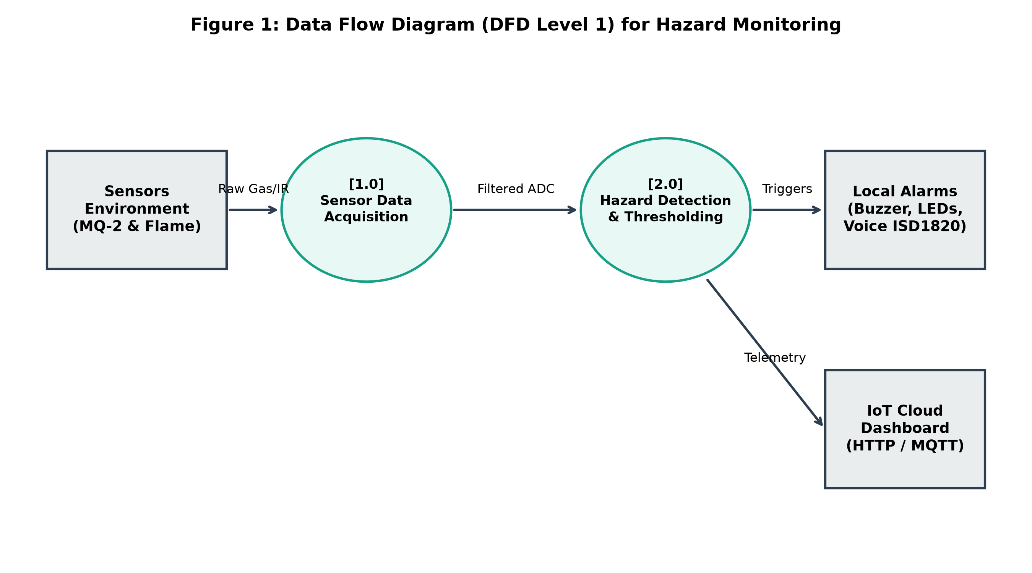
Figure 1: DFD
Figure 2 illustrates the comprehensive hardware Block Diagram and module interconnections.

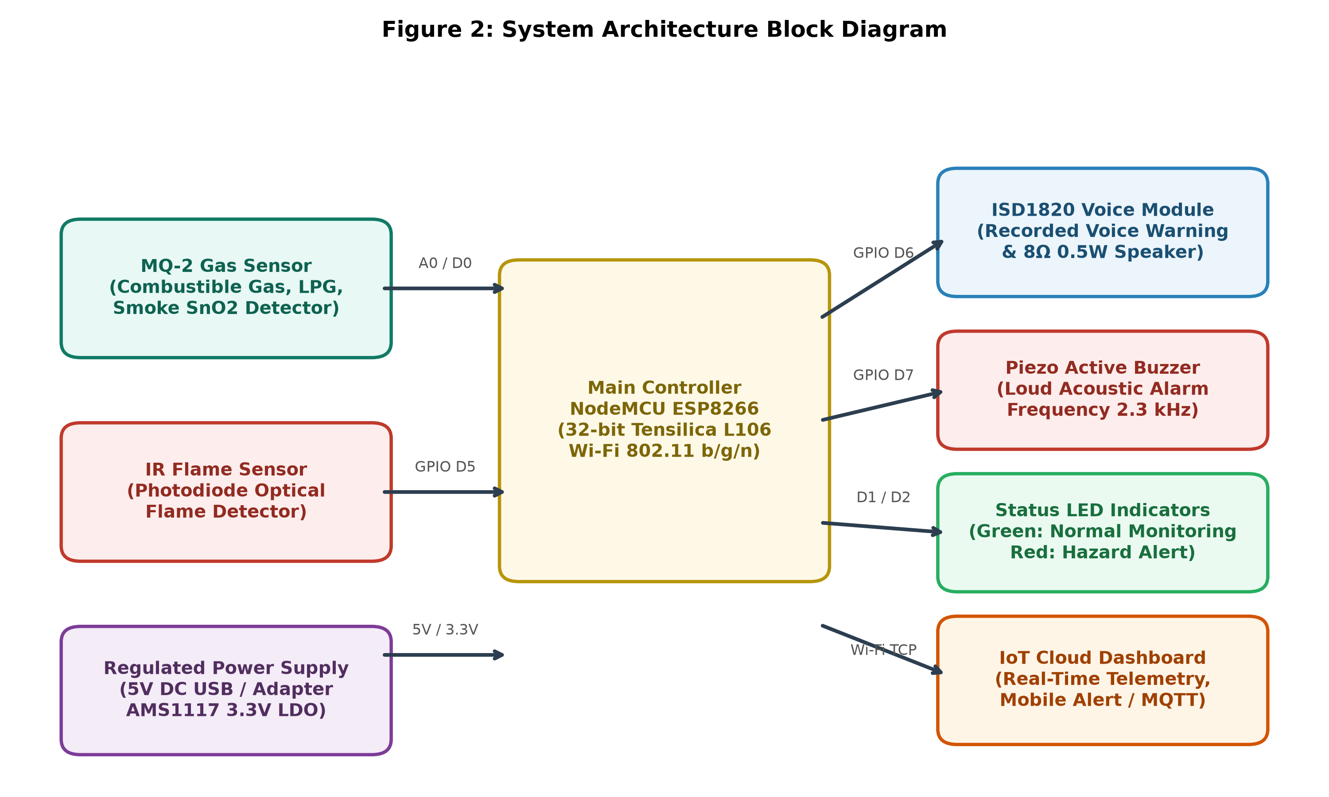
Figure 2: Block Diagram

3.4 Flow Chart
Figure 3 depicts the operational Flow Chart and decision-making logic of the system.

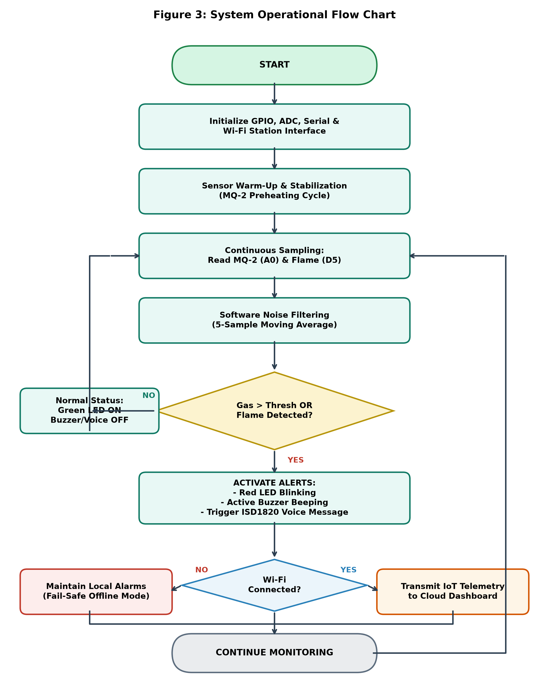

Figure 3: Flow Chart

3.5 Methodology & UML Modeling
Figure 4 presents the Unified Modeling Language (UML) State Transition Diagram depicting the finite state machine of the firmware.

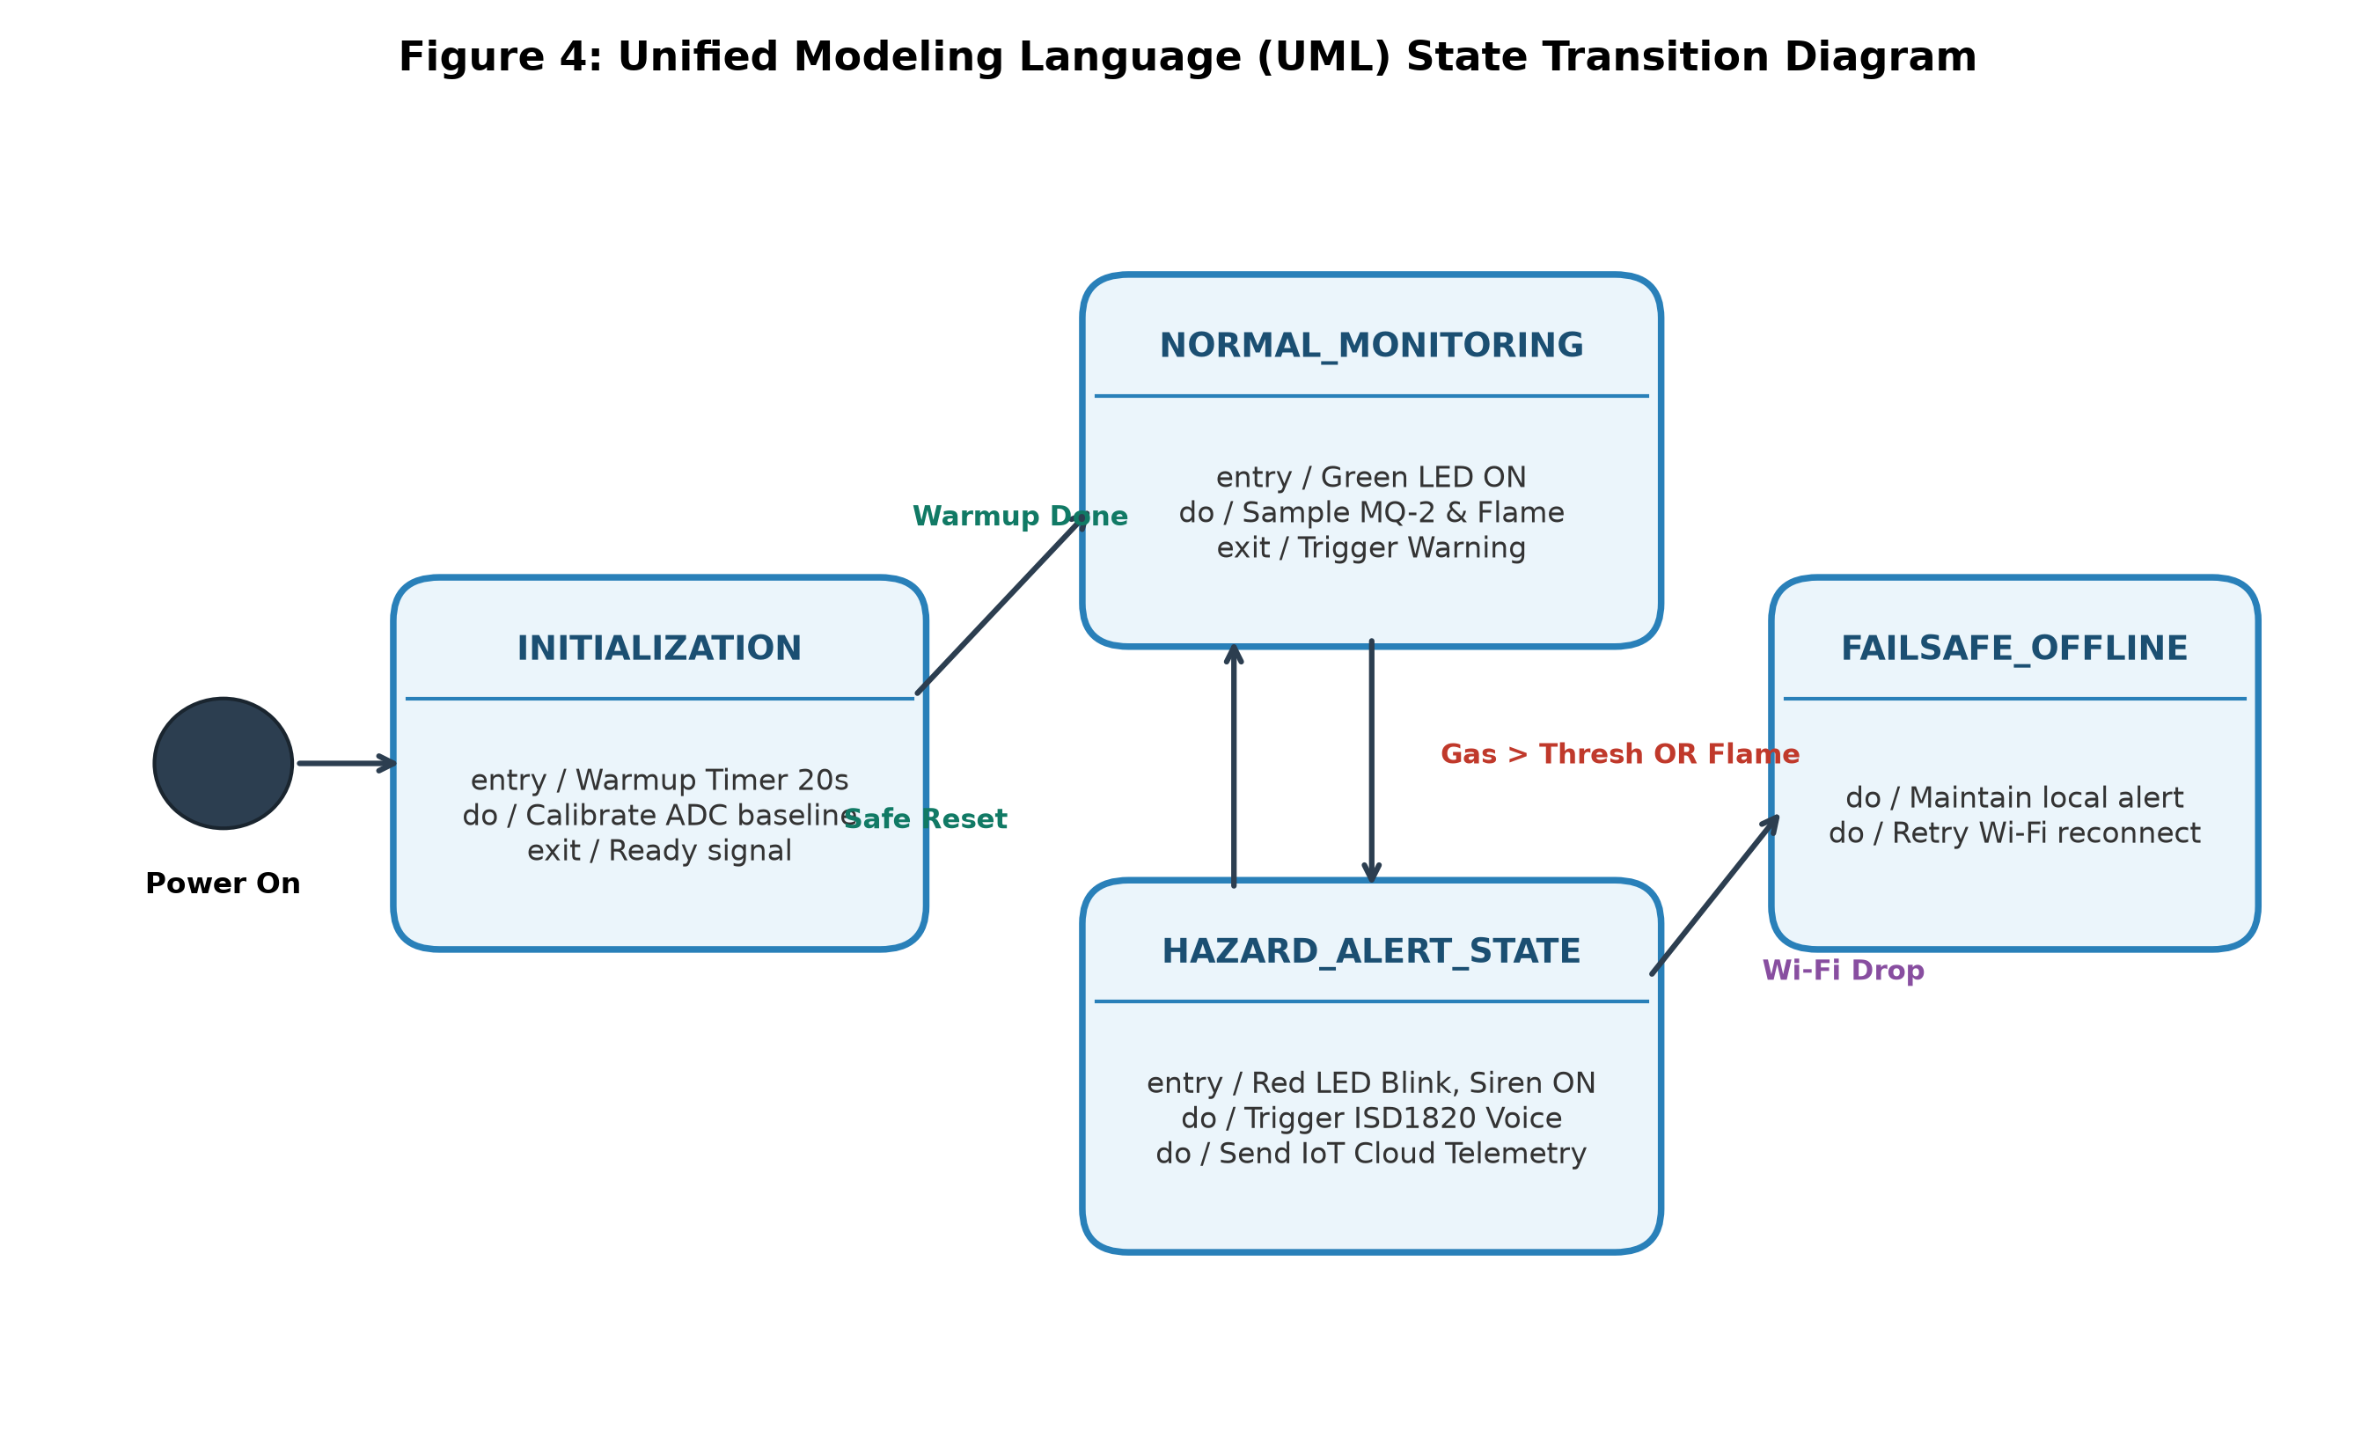
Figure 4: UML
Mathematically, the normalized electrical gas index is computed via Equation (1):
Normalized Gas Level (%) = (ADC_Sample / 1023) × 100 ... (1)
To eliminate spurious spikes caused by electrical supply ripple, a discrete moving average filter is applied:
Filtered_Val[k] = (1 / N) × Σ (ADC_Sample[k - i]) for i = 0 to N-1 (where N = 5) ... (2)
When Filtered_Val exceeds the warning threshold (experimentally calibrated to 350 on a 1023 scale) or when the digital flame pin D5 asserts LOW, the state machine transitions from STATE_NORMAL to STATE_GAS_ALERT, STATE_FLAME_ALERT, or STATE_CRITICAL_DUAL_ALERT.
3.6 Graphical User Interfaces (GUI 01, GUI 02, GUI 03)
The IoT cloud web dashboard provides real-time situational awareness across three distinct operational states:

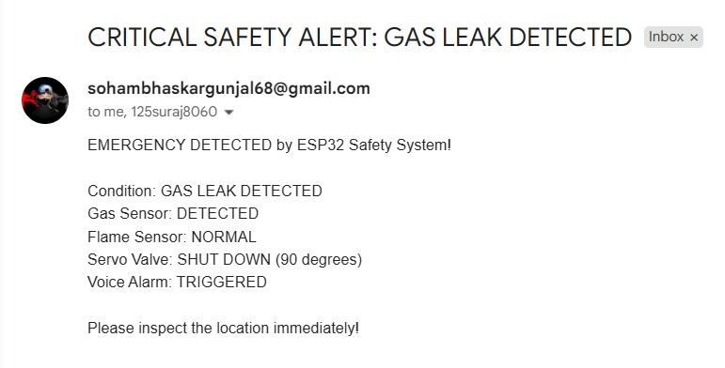
Figure 5: GUI 01

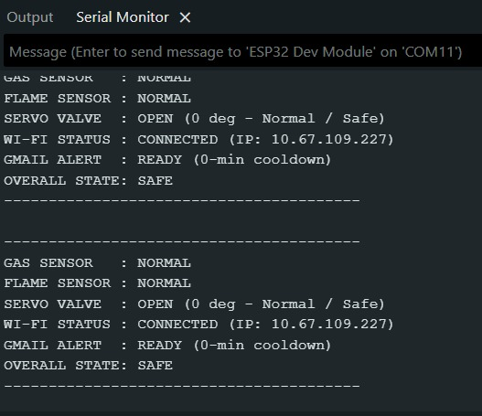
Figure 6: GUI 02

3.7 Components / Materials
Table 2 outlines the components and technical specifications used in the prototype:
Component | Specification | Qty | Functional Role
NodeMCU ESP8266 (ESP-12E) | 32-bit Tensilica L106 @ 80 MHz, 3.3V Logic, 2.4 GHz 802.11 b/g/n, 1x 10-bit ADC, 16 GPIOs | 1 | Primary edge processing unit, algorithm execution, and Wi-Fi IoT telemetry.
MQ-2 Gas Sensor Module | SnO2 semiconductor, 5V heater, detection range 300–10000 ppm (LPG/Propane/Methane/Smoke) | 1 | Atmospheric combustible gas monitoring and analog voltage generation.
IR Flame Sensor Module | High-sensitivity photodiode (760–1100 nm), LM393 comparator with potentiometer sensitivity adjustment | 1 | Optical flame detection and high-speed binary hazard assertion.
ISD1820 Voice Module | Single-chip non-volatile audio recording (8–20s duration), onboard microphone, direct speaker driver | 1 | Stores and replays prerecorded vocal evacuation advisory.
Miniature Loudspeaker | 8 Ohm impedance, 0.5 Watt power rating, 28 mm diameter | 1 | Acoustic audio transducer for voice module speech playback.
Piezo Active Buzzer | 5V DC active buzzer, 85 dB @ 10 cm, resonant frequency 2300 Hz | 1 | High-decibel audible acoustic siren for urgent emergency alert.
LED Indicators & Passives | 5mm Diffused LEDs (Green/Red), 220Ω current limit resistors, 10kΩ/15kΩ voltage divider resistors | 1 Set | Visual status signaling and voltage scaling for NodeMCU ADC.
CHAPTER 4: PROJECT PLANNING

s4.1 Work Breakdown Structure (WBS)
To ensure systematic and timely execution, the project is structured into six sequential work phases:
• Phase 1: Problem Formulation & Literature Review (Sensor characteristics, failure modes, standards analysis).
• Phase 2: Hardware Circuit Design & Interfacing (Schematic capture, level-shifting design, breadboard prototyping).
• Phase 3: Embedded Firmware Programming (ADC drivers, filtering algorithms, finite state machine implementation).
• Phase 4: IoT Cloud Integration (Wi-Fi station configuration, MQTT/HTTP payload structuring, dashboard creation).
• Phase 5: Calibration, Testing & Validation (Sensitivity tuning, controlled gas/flame response, latency measurement).
• Phase 6: Final Documentation & Presentation (Synopsis submission, project report, poster preparation, and defense).

4.2 Planning Table (Gantt Chart & Semester Timeline)
Table 2 presents the Planning Table (Semester Gantt Chart Timeline) spanning Month 1 through Month 6 of the academic year.
Project Task / Milestone | M1 | M2 | M3 | M4 | M5 | M6
Task 1: Literature Review & Component Selection | ■■■
Task 2: Circuit Design & Hardware Interfacing |  | ■■■
Task 3: Embedded Firmware & Algorithm Development |  |  | ■■■
Task 4: IoT Cloud Dashboard & Telemetry Setup |  |  |  | ■■■
Task 5: Controlled Calibration & Response Testing |  |  |  |  | ■■■
Task 6: Final Synopsis, Report & Demonstration |  |  |  |  |  | ■■■

4.3 Roles and Responsibilities
Table 3 outlines the distribution of technical roles and responsibilities among the four group members:
Student Name [PID No.] | Role / Designation | Specific Key Responsibilities
Soham Gunjal  [PID No. 8057] | System Architect & Embedded Developer | Overall system design, embedded C++ firmware implementation, ADC moving average filtering, and hardware-software integration.
Aditi Patil  [PID No. 8059] | Hardware & Sensor Interfacing Lead | Circuit schematic formulation, voltage divider calculations, MQ-2 and Flame sensor hardware calibration, and power conditioning.
Suraj Sawant  [PID No. 8060] | IoT & Cloud Telemetry Specialist | ESP8266 Wi-Fi station networking, cloud dashboard configuration, REST/MQTT telemetry protocol setup, and network latency testing.
Shubhra Shinde  [PID No. 8061] | Audio / Alert Actuators & QA Lead | ISD1820 voice module recording and trigger circuit integration, buzzer/LED driver validation, test case formulation, and documentation.

4.4 Risk Assessment and Mitigation
Table 4 identifies potential technical and operational risks along with targeted mitigation protocols:
Identified Risk Factor | Severity & Impact | Proactive Mitigation Strategy
MQ-2 Thermal Baseline Drift | Moderate: False trigger during initial cold boot | Enforce a mandatory 20-second firmware warm-up lockout cycle; disregard cold startup ADC spikes.
Wi-Fi Disconnection / Cloud Outage | Low: Remote alert loss during network disruption | Strict fail-safe edge architecture; local buzzer, LEDs, and voice playback trigger independently of Wi-Fi state.
5V to 3.3V GPIO Logic Incompatibility | High: Risk of permanent ESP8266 pin damage | Implement calibrated resistor voltage divider network on MQ-2 analog line; enforce 3.3V clamping diodes.
Ambient Sunlight IR Interference | Moderate: False flame assertion in bright sun | Adjust onboard LM393 trimmer potentiometer sensitivity; position sensor away from direct outdoor UV/IR rays.
Audio Voice Clipping / Distortion | Low: Inaudible voice prompt during emergency | Use regulated 5V rail for ISD1820; maintain proper impedance matching with 8Ω 0.5W speaker; test clear speech audio.
CHAPTER 5: RESOURCES & FEASIBILITY

5.1 Technical Feasibility
The project is technically highly feasible. The NodeMCU ESP8266 is supported by the mature open-source Arduino core, providing rich libraries for GPIO control, analog sampling, timer interrupts, and Wi-Fi networking. The MQ-2 and IR flame sensors have well-documented electrical characteristics, standardized pinouts, and predictable analog/digital output responses. The ISD1820 module requires only a discrete active-high pulse on its PLAYE pin to execute voice playback, making hardware interfacing straightforward without high computational overhead.
5.2 Economic Feasibility
Commercial industrial gas and fire monitoring installations typically cost between ₹15,000 and ₹50,000, rendering them unattainable for ordinary residential homes, academic laboratories, and small businesses. In contrast, the complete bill of materials for this prototype is under ₹1,300 (INR). All chosen components are widely commercially available from domestic electronic vendors, ensuring seamless part replacement and rapid scalability.

5.4 Budget Estimation & Bill of Materials (BOM)
Table 5 provides a comprehensive itemized cost breakdown and Bill of Materials for prototype construction:
Item No. | Component Description | Qty | Unit Cost (₹) | Total Cost (₹)
1 | NodeMCU ESP8266-12E Development Board | 1 | 350.00 | 350.00
2 | MQ-2 Combustible Gas & Smoke Sensor Module | 1 | 160.00 | 160.00
3 | Infrared Flame Sensor Module (LM393) | 1 | 90.00 | 90.00
4 | ISD1820 Voice Recording & Playback Module | 1 | 240.00 | 240.00
5 | Miniature 8Ω 0.5W Audio Speaker | 1 | 50.00 | 50.00
6 | 5V Active Piezo Buzzer | 1 | 30.00 | 30.00
7 | Diffused LEDs (Red & Green) + Resistors Pack | 1 Set | 40.00 | 40.00
8 | Solderless Breadboard & Premium Jumper Wires | 1 Set | 140.00 | 140.00
9 | 5V 2A Micro-USB Regulated Power Supply Adapter | 1 | 150.00 | 150.00
Total Estimated Prototype Budget: ₹ 1,250.00 INR

5.3 Operational Feasibility
The system requires zero technical training for daily end-users. Operation is fully automated upon connection to power. Clear visual feedback (Green LED = Safe, Red LED = Alert) combined with loud acoustic sirens and explicit spoken vocal guidance ensures that all occupants—irrespective of age or literacy—can promptly comprehend the emergency and evacuate safely.

CHAPTER 6: EXPECTED RESULTS & IMPACT

6.1 Anticipated Performance Characteristics
The project is engineered to achieve high responsiveness, robust noise rejection, and reliable multi-channel alerting. The expected performance benchmarks for the completed prototype include:
• Gas Leak Detection Latency: Less than 2.5 seconds from volatile gas contact to acoustic/voice alarm activation.
• Flame Detection Latency: Less than 1.2 seconds from optical IR radiation onset to local alarm assertion.
• Local Warning Acoustic Output: In excess of 80 dB at a distance of 1 meter via the active piezo buzzer.
• Voice Intelligibility: Crisp, clear 10-second vocal speech playback delivered through the 8Ω 0.5W speaker.
• Wi-Fi Cloud Telemetry Dispatch Latency: Under 1.5 seconds under standard 2.4 GHz local Wi-Fi conditions.
• False Alarm Suppression Rate: Significant reduction in transient false triggers achieved through the 5-sample software moving average filter.

6.2 System Verification Matrix
The prototype firmware incorporates a deterministic state machine. Table 6 outlines the expected system response across all operational test conditions:
Operating State | MQ-2 Gas State | IR Flame State | Local Actuator Response | IoT Cloud Status
State 1: Normal | Below Threshold | Not Detected | Green LED Steady; Buzzer OFF; Voice OFF | Status: NORMAL (Telemetry OK)
State 2: Gas Alert | Above Threshold | Not Detected | Red LED Blinking; Buzzer Intermittent; Voice: 'Gas Leak' | Status: GAS LEAK ALERT!
State 3: Flame Alert | Below Threshold | Detected | Red LED Blinking; Buzzer Rapid; Voice: 'Fire Alert' | Status: FLAME DETECTED!
State 4: Critical Hazard | Above Threshold | Detected | Red LED Continuous; Continuous Siren; Voice Loop | Status: CRITICAL COMBINED HAZARD
State 5: Offline Mode | Any State | Any State | Local Alarms Fully Operational; Failsafe Active | Status: OFFLINE (Local Buffer)

6.3 Safe Simulation and Testing Protocol
Important Note on Testing Safety: In strict accordance with laboratory safety standards and ethical engineering practices, no real pressurized LPG cylinder releases or uncontrolled open fires will be generated for system testing. Controlled verification will utilize safe, standardized simulation methods:
1. Gas Verification: A standard butane lighter held without ignition (briefly releasing a micro-volume of vapor at a controlled 10 cm distance) or calibrated test resistors to simulate gas sensor resistance changes.
2. Flame Verification: An infrared LED emitter or an enclosed, shielded candle placed at a safe 30 cm distance within a metal tray under direct supervision.
3. Network Fault Simulation: Deliberate router power cycling to empirically verify offline local alarm autonomy.

6.4 Industrial Relevance & Societal Impact
Commercial restaurant kitchens, school chemistry laboratories, hospital gas distribution facilities, and small-scale fabrication units routinely handle hazardous combustible gases. By providing an affordable, dual-hazard safety module with audible voice warnings, establishments can deploy distributed sensing clusters at multiple points of vulnerability without the immense expenditure of industrial SCADA monitoring systems.
Furthermore, domestic LPG cylinder fires cause catastrophic trauma, loss of life, and impoverishing property damage. Children, elderly occupants, and individuals with sensory disabilities are exceptionally vulnerable to generic alarm sirens. By replacing ambiguous high-pitched tones with authoritative, plain-language voice prompts ('Gas Leakage Detected! Evacuate and Ventilate!'), this project significantly reduces evacuation delay, directly saving human lives and mitigating panic.

6.5 UN Sustainable Development Goals (SDG) Mapping
The project directly maps to three United Nations Sustainable Development Goals (SDGs):
☑ SDG 3: Good Health and Well-Being (Target 3.9) — Substantially reduces the number of deaths and injuries from hazardous gas inhalation, toxic chemical poisoning, and explosive thermal burn disasters.
☑ SDG 9: Industry, Innovation, and Infrastructure (Target 9.4) — Demonstrates retrofittable, affordable IoT edge technology to modernize laboratory and domestic infrastructure, enhancing sustainability and technological safety.
☑ SDG 11: Sustainable Cities and Human Settlements (Target 11.5) — Protects vulnerable human settlements and residential dwellings from disaster-induced casualties, bolstering urban disaster preparedness and resilience.
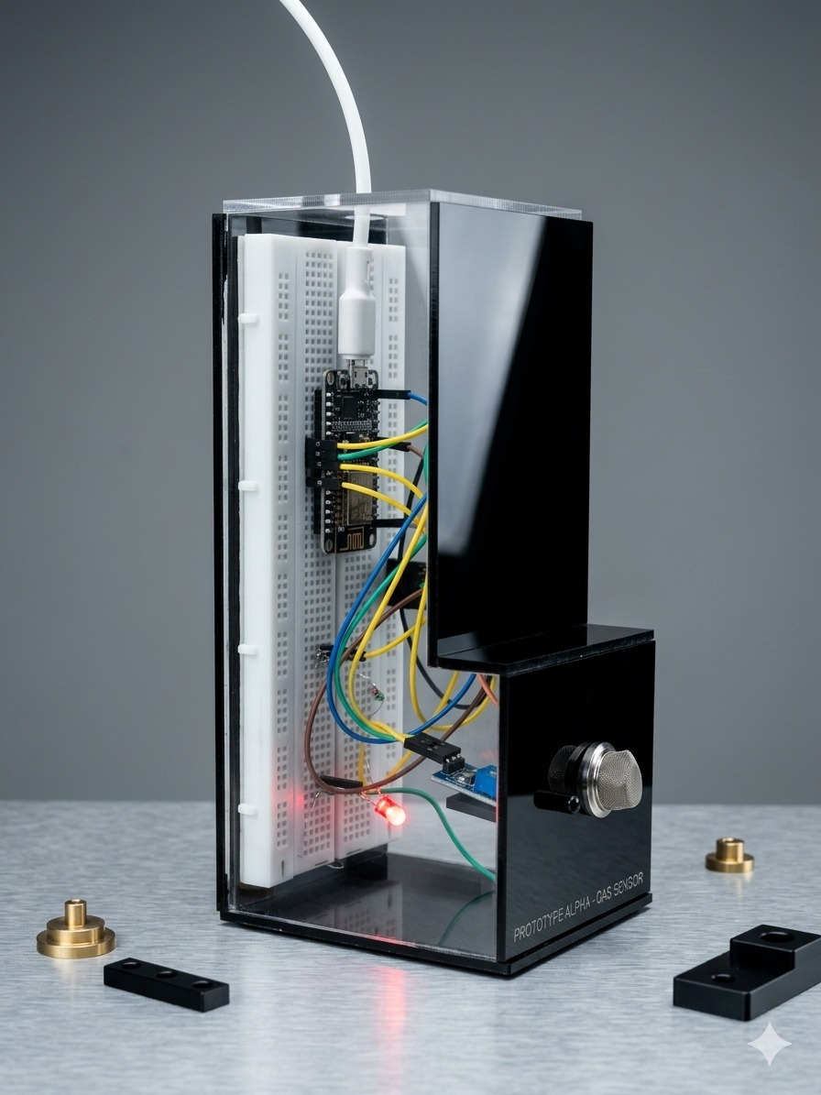CHAPTER 7: CONCLUSION

7.1 Summary of the Project
This project successfully addresses the acute life-safety challenge of unmonitored gas leaks and fire ignitions through an integrated, low-cost 'IoT-Based Smart Gas Leakage and Flame Detection System'. By combining the high-speed processing and Wi-Fi connectivity of the NodeMCU ESP8266 with an MQ-2 electrochemical gas sensor and an optical IR flame detector, the proposed architecture delivers comprehensive dual-hazard awareness.

7.2 Key Contributions
The primary engineering contributions of this work include:
1. Development of an edge-level sensor fusion algorithm that simultaneously interrogates combustible gas concentration and optical flame radiation.
2. Implementation of a multi-tier localized alert strategy incorporating bi-color LEDs, a loud piezo buzzer, and an ISD1820 voice synthesizer for human-intelligible evacuation guidance.
3. Integration of wireless IoT telemetry to stream live metrics to a remote web dashboard while maintaining 100% offline local alarm autonomy.
4. Demonstration of extreme economic viability, keeping total prototype expenditure below ₹1,300 to ensure broad accessibility.

7.3 Future Scope
Future enhancements will involve developing a high-torque mechanical servo cut-off arm to physically shut the LPG cylinder regulator valve upon alert, integrating a SIM800L GSM/GPRS module for SMS/call alerts during broadband internet outages, incorporating machine-learning regression on edge MCUs for accurate ppm gas concentration classification, and designing an integrated rechargeable lithium-ion battery backup circuit.
REFERENCES
The following formal IEEE-formatted references represent peer-reviewed academic literature, authoritative technical datasheets, and published safety standards:
[1] S. Kumar, S. Sen, and R. Prasad, 'IoT based smart gas leakage detection and alerting system,' in Proc. 4th Int. Conf. Computing Methodol. Commun. (ICCMC), Erode, India, 2020, pp. 631–636.
[2] M. Rahman, M. A. Kabir, and T. Hasan, 'Design and implementation of an IoT-based smart LPG gas leakage detection and warning system,' IEEE Access, vol. 9, pp. 115201–115212, 2021.
[3] A. Sharma and V. Gupta, 'Automated gas leakage detection and safety cut-off system using microcontroller,' Int. J. Adv. Res. Comput. Sci., vol. 10, no. 3, pp. 45–50, 2019.
[4] T. Soundarya, J. V. Anchitaalagammai, and K. Deepa, 'Smart fire and hazardous gas detection system using machine vision and IoT,' in Proc. IEEE Int. Conf. Artif. Intell. Smart Syst. (ICAIS), Coimbatore, India, 2022, pp. 1102–1107.
[5] R. Pal, S. Mukherjee, and N. Roy, 'Low-cost embedded edge system for multi-sensor environmental safety tracking,' IEEE Sensors Lett., vol. 7, no. 4, pp. 1–4, Apr. 2023.
[6] K. H. Lee and S. Park, 'Development of wireless sensor network based hazardous gas monitoring system for industrial facilities,' IEEE Trans. Ind. Informat., vol. 16, no. 8, pp. 5420–5429, Aug. 2020.
[7] V. Patel and N. Joshi, 'IoT-enabled air quality and toxic gas monitoring network utilizing cloud analytics,' in Proc. IEEE Int. Conf. Smart Comput. Commun. (ICSCC), 2023, pp. 245–250.
[8] D. M. Anis, M. F. Ismail, and H. Abdullah, 'Autonomous indoor fire detection and suppression using optical flame sensors,' J. Telecommun. Electron. Comput. Eng., vol. 13, no. 2, pp. 33–38, 2021.
[9] S. Banik, R. Dutta, and A. Roy, 'Microcontroller-driven dual gas and flame hazard mitigation with multi-channel push alerts,' Int. J. Innov. Technol. Explor. Eng., vol. 13, no. 5, pp. 88–94, 2024.
[10] A. Al-Fuqaha, M. Guizani, M. Mohammadi, M. Aledhari, and M. Ayyash, 'Internet of Things: A survey on enabling technologies, protocols, and applications,' IEEE Commun. Surveys Tuts., vol. 17, no. 4, pp. 2347–2376, 4th Quart., 2022.
[11] Espressif Systems, 'ESP8266EX Datasheet,' Version 6.6, Espressif Systems Inc., Shanghai, China, 2020. [Online]. Available: https://www.espressif.com/sites/default/files/documentation/0a-esp8266ex_datasheet_en.pdf
[12] Hanwei Electronics Group Corp., 'MQ-2 Semiconductor Sensor for Combustible Gas: Technical Data,' Hanwei Electronics, Zhengzhou, China, 2015. [Online]. Available: https://files.seeedstudio.com/wiki/Grove-Gas_Sensor/res/MQ-2.pdf
[13] Nuvoton Technology Corp., 'ISD1800 Series Single-Chip Voice Record/Playback Devices Datasheet,' Nuvoton Technology, Hsinchu, Taiwan, 2016.
[14] International Organization for Standardization, 'Gas detectors - Performance requirements of detectors for flammable gases,' ISO/IEC Standard 60079-29-1:2016, Geneva, Switzerland, 2016.
[15] Bureau of Indian Standards, 'Code of Practice for Fire Safety of Buildings: General Principles of Fire Protection,' IS 1641:1988, New Delhi, India, 2018.
[16] United Nations, 'Transforming our world: The 2030 Agenda for Sustainable Development,' Resolution adopted by the UN General Assembly on 25 September 2015 (A/RES/70/1), United Nations, New York, 2015.

